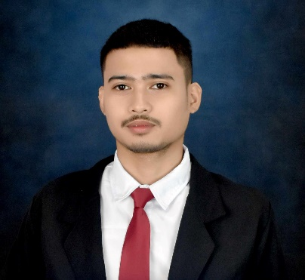

Darmil R. Pepito

186 J. Sumulong st., San Jose, Rodriguez, rizal

**+63 965-034-9357 / +63 928-267-8053**

dampepito5@gmail.com

**__________________________________________________________________________________**

**Objective:**

Seeking a position as an IT Personnel/Jr. Developer or any position that will expand my learnings, knowledge, skills and will challenge me to perform my full potential while learning and to enhance my desire to grow professionally. Ready to help team achieve company goals.

**PERSONAL DATA:**

**Birthday**  February 5, 2001

**Birthplace** Montalban

**Sex**  Male

**Height** 5’9 “

**Weight** 154 lbs.

**Civil Status** Single

**Citizenship** Filipino

**Religion** Roman Catholic

**Father’s Name:** Dario Pepito

**Occupation:** Tricycle Driver

**Mother’s Name:** Mildred Pepito

**Occupation:** Housewife

**Educational attainment:**

**tertiary : ACLC COLLEGE OF MARIKINA**

**Bachelor of Science in Information System**

June 2019 –2023

**SECONDARY : SENIOR HIGH SCHOOL**

**CASAP Rodriguez**

85 D Bgry. San Jose, Rodriguez, Rizal

2017 – 2019

**JUNIOR HIGH SCHOOL**

**CASAP Rodriguez**

85 D Bgry. San Jose, Rodriguez, Rizal

2016 – 2017

**San Jose National Highscool**

San Jose, Rodriguez, Rizal

2013 – 2016

**PRIMARY : San Jose Elementary School**

San Jose, Rodriguez, Rizal

2007 – 2013

**Skills:**

* Computer literate
* Basic Troubleshooting
* HTML 
* CSS ⬆
* Knowledgeable about JavaScript ⬅, MySQL⬅ and PHP⬆

**AFFLIATION CERTIFICATES:**

* CSS Complete Course For Beginners – udemy
* JavaScript for Beginners - The Complete introduction to JS - udemy

**CHARACTER REFERENCE**

**09979377561**

**Ms. Aila Andrea N. Olorvida, LPT**

Faculty Head at ACLC College of Marikina

**09955996875**

**Mr. Michael Kien C. Oseo, LPT**

IT Head at ACLC College of Marikina

**09973183825**

**Ms. Johnora T. Tibay, LPT**

Instructor at ACLC College of Marikina

I hereby certify that all information herein is true and correct to the best of my knowledge and ability

_____________________________

Darmil R. Pepito